2025 SPRING WILDFIRE TOWN HALL

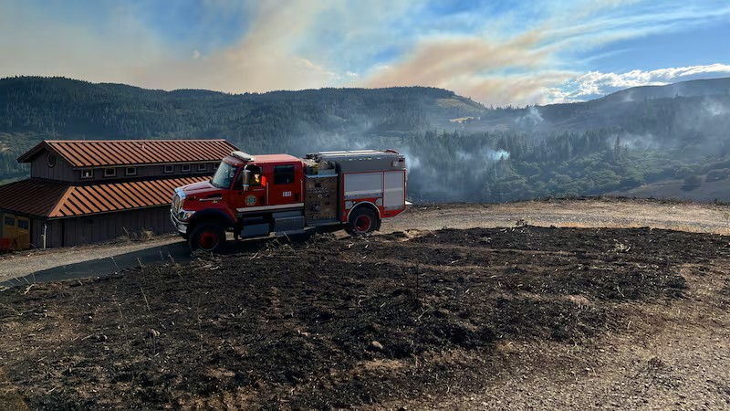

The Mosier Fire District would like to invite all residents to the 2025 Spring Wildfire Town Hall.

WHEN: Saturday May 3rd

WHERE: Mosier Community School (gymnasium)

TIME: 9:00 am until 1:00 pm

Tentatively, representatives from our partner agencies will be there to answer any questions that you may have before the fire season:

Donuts, Water, and Coffee will be provided while supplies last