2024 SPRING WILDFIRE TOWN HALL
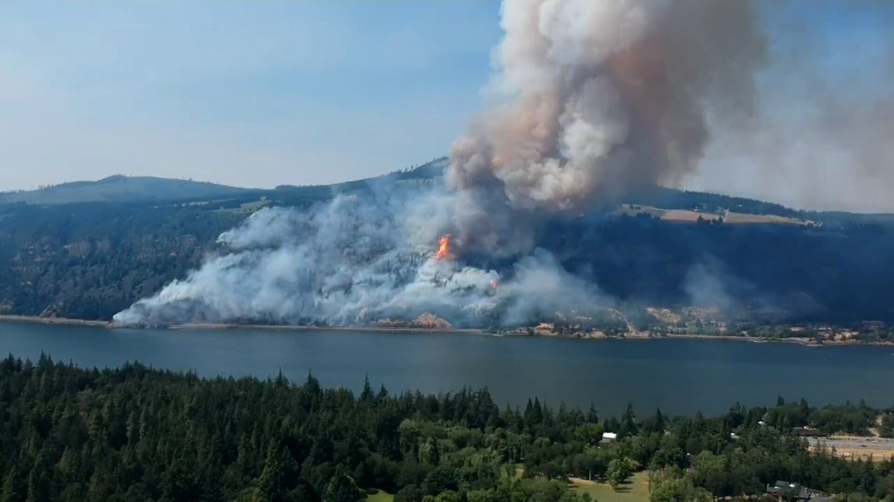

The Mosier Fire District would like to invite all residents of the district to the 2024 Spring Wildfire Town Hall.

WHEN: Saturday March 30th
WHERE: Mosier Grange (1000 4th Ave)
TIME: 9:00 am until 1:00 pm

Tentatively, representatives from our partner agencies will be there to answer any questions that you may have before the fire season:
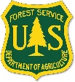
Donuts Water, and Coffee will be provided, while supplies last

